

Visualizing Sustainability: A Cognos-Based Analysis Of Global Trends (2000-2023)

# 1 INTRODUCTION

1.1 Overview

The Sustainable Development Report (SDR) reviews progress made each year on the Sustainable Development Goals since their adoption by the 193 UN Member States in 2015. At the halfway mark to 2030, the Sustainable Development Report 2023 takes stock of progress made and discusses priorities to restore and accelerate SDG progress. Published on the eve of the 2023 Paris Summit for a New Global Financial Pact, this year’s edition focuses specifically on the need to scale up development finance and to reform the global financial architecture to support the SDGs.

1.2 Purpose

# The Sustainable Development Report (SDR) reviews progress made each year on the Sustainable Development Goals since their adoption by the 193 UN Member States in 2015. At the halfway mark to 2030, the Sustainable Development Report 2023 takes stock of progress made and discusses priorities to restore and accelerate SDG progress. Published on the eve of the 2023 Paris Summit for a New Global Financial Pact, this year’s edition focuses specifically on the need to scale up development finance and to reform the global financial architecture to support the SDGs

# 2 LITERATURE SURVEY

# A literature survey on the Sustainable Development Report 2023 dataset reveals a growing body of research and analysis centered around sustainability and the progress of countries toward achieving the United Nations' Sustainable Development Goals (SDGs). Scholars, policymakers, and organizations have recognized the significance of this dataset in assessing and advancing sustainability efforts on a global scale.he dataset has become a critical resource for policymakers, guiding the development and adjustment of policies and strategies to address specific SDGs. It assists in identifying areas requiring improvement and highlighting successful strategies.Some studies critically evaluate the dataset itself, discussing data accuracy, sources, and limitations. Researchers emphasize the importance of transparent and reliable data for meaningful sustainability assessments.

# 3 THEORITICAL ANALYSIS

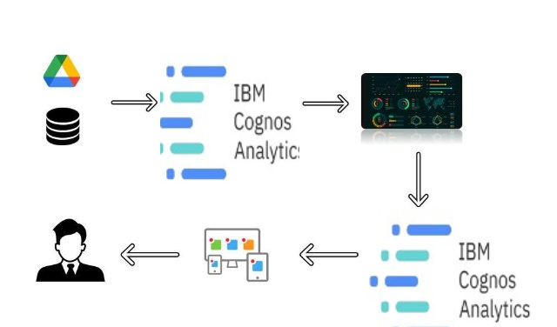

1. **EXPERIMENTAL INVESTIGATIONS**

Analysis or the investigation made while working on the solution.

1. **FLOWCHART**

Diagram showing the control flow of the solution

1. **RESULT**

Final findings (Output) of the project along with screenshots.

1. **ADVANTAGES & DISADVANTAGES**

List of advantages and disadvantages of the proposed solution

1. **APPLICATIONS**

The areas where this solution can be applied

1. **CONCLUSION**

Conclusion summarizing the entire work and findings.

# 10 FUTURE SCOPE

Enhancements that can be made in the future.

 Project Report Titles

# 11 BIBILOGRAPHY

References of previous works or websites visited/books referred for analysis about the project, solution previous findings etc.

# APPENDIX

A. Source Code

Attach the code for the solution built.

**Note: Limit the report to 15 pages.**